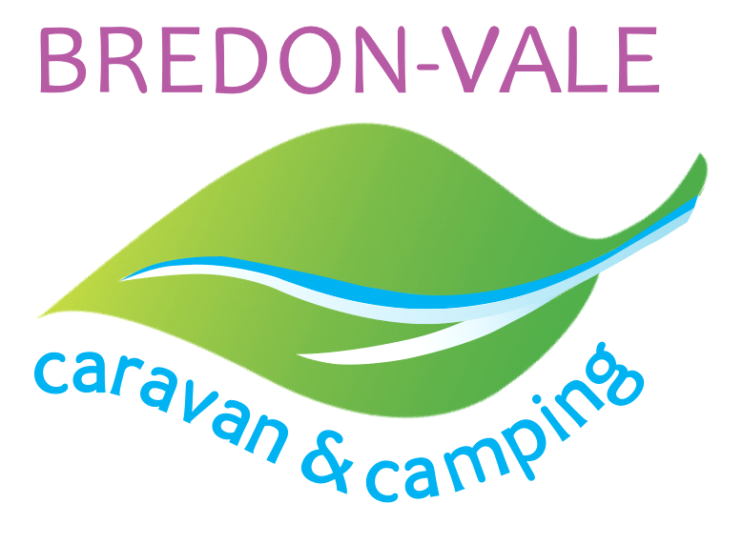

Bredon-Vale Caravan and Camping reserve the right to decide if a refund is made or a credit
given. Please phone us in the first instance to explain your situation.

Refund, cancellation and amendment policy
Should you wish to cancel your holiday, you will be charged the appropriate cancellation fee as per the below. By making a booking, you agree that this refund, cancellation and amendment policy will apply to your booking. When we refer to “you” or “your”, we mean the camper – the person making the reservation.

Cancellations and refunds
We recommend that you take out enough travel insurance to cover you for your total stay,
including cancellation cover. Should a travel ban be implemented, guests should claim any refunds or costs against their travel insurance.

We are not liable for refunds or expenses you incur in the event we are prevented from fulfilling your booking as a result of circumstances beyond our control. Such circumstances shall include (but not be limited to) war, terrorism, riots or civil unrest, industrial action, flooding, natural disaster, epidemics, health risks or such similar events (“Force Majeure”). We recommend that you have adequate holiday insurance in place to cover this.

The reservation may be cancelled at any time by the visitor. If a cancellation occurs the following refund policy applies:

Please note: all payments must be paid a week before arrival in full to secure your pitch.

Cancellation 28 days beforehand – 100% refund
Cancellation between 7 and 28 days beforehand – refund minus deposit paid
Cancellation between 2 and 7 days beforehand – 50% will be refunded
Cancellation 36 hours of arrival – No refund

* Refunds cannot be given in the event of leaving due to inclement weather or the decision to cut short a holiday which has been previously paid for.
* In the event of severe weather, the need to evacuate the site or if the pitch becomes unusable, inaccessible or unavailable due to circumstances beyond the visitor’s control either prior to or during a stay, a full refund will be offered, this decision will be made by the site manager.

* If you do not turn up when you have made a booking, by 10pm on the first day of the booking (without letting the site know), we will treat you as having cancelled the booking and you will not be entitled to a refund. Note: If you believe that your arrival will be delayed beyond 8pm it is important that you call us in order that we can ensure there is someone available to greet you on arrival.

* If adverse circumstances, for example flooding, result in the Proprietor cancelling your booking at any time, a full refund of your deposit or unused camping fees will be made. If the site needs evacuating in an emergency situation and there is insufficient time to process a refund on site, you will be contacted as soon as possible after the evacuation in order for the refund to be arranged.

* Admission to the site is at the discretion of the Proprietor or, in their absence, another staff member. We let the pitch, tent or Unique Stay to you with the expectation that you will follow the usual customs of good camping, and with due regard to the comfort, health and safety of yourself and others. We reserve the right to ask you to leave at any point of your stay if the behaviour of any member of your party is unacceptable to us and no refund of monies will be paid.

* Please note that we cannot accept bookings from persons under the age of 18 unless they are going to be accompanied by an adult age 21+ for the duration of their stay.

